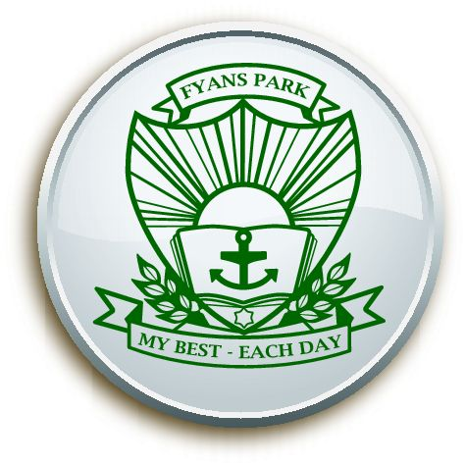
2020 Annual Implementation Plan

School Name: Surfside Primary School Principal: Peter Walsh Assistant Principal: Linda Giggins

AIP Action | Staff at Surfside Primary School to work collaboratively and consistently to improve student achievement, engagement, wellbeing and community links. |  | AIP One-year targets | NAPLAN: % of students in top 2 bands Yr 5 (Reading) – 30% or above (2019-25%)  % of students in top 2 bands Yr 5 (Numeracy) – 28% or above (2019-25%)  % of students in top 2 bands Yr 5 (Writing) – 30% or above (2019-25%)  % of students achieving high/med growth (Years 3-5) Writing 40% (2019-35%)  % of students achieving high/med growth (Years 3-5) Numeracy 25% (2019-19%)  Staff Opinion Survey: School Climate – Collective efficacy – 90% positive response (2019-86.7%)  – Academic emphasis – 75% positive (2019-69.7%)  Attitude to School Survey: Motivation and Interest - 85% positive response or above (2019-82%)  Sense of confidence - 85% positive response or above (2019-81.6%)
CYCLE No. 1 - Term 1 Annual Implementation Plan Commencing on: 28/01/2020 Concluding on: 18/12/2020
Goals and Key Improvement Strategies  Priorities as agreed with staff and outlined in the school’s AIP designed to improve achievement standards and increase the wellbeing of all students and staff. | Evidence of Impact  To be written at the start of the cycle. The milestones and quantitative data that will show evidence of success in implementing the focus areas.
 |  | B | C | E | E
1.ACHIEVEMENT – Build the knowledge and capacity of school leaders to drive whole school improvement initiatives and build teacher capacity  Establish professional learning teams that collaborate and collectively inquire into best practice to achieve common goals that will impact on improved classroom practices and lead to improved student outcomes  KIS 1 – To empower students to engage in challenging, authentic and purposeful mathematical problem solving | 1- To build teacher, student and community understanding of learning characteristics and dispositions in numeracy  2- To build teacher and student capacity in the four proficiencies in numeracy (Understanding, Fluency, Problem Solving and Reasoning)  3- To build student proficiency and community understanding in solving and exploring challenging tasks  As educators we will:  - Develop and support skills to devise open ended questions  - Develop their understanding and the implementation of the four proficiencies (Reasoning, Fluency, Problem-Solving, Understanding)  - Utilise the Surfside PS instructional model and modify to allow for rich problem solving in activities  - Utilise a range of High Impact Teaching Strategies and be evident in planners  - Develop an understanding of the desired characteristics of effective and confident maths learners  - Capatilise on links with real world opportunities and practical applications (eg: kitchen garden program, sport, environmental, art, 21st Century Learning and community connections)
KIS 2 – To empower students to engage in creating authentic and purposeful writing | 1- To develop and implement a sequential progression of writers workshop and the 6+1 traits of writing  2- To establish opportunities for authentic and purposeful writing experiences  3- To establish common teacher understanding and consistent practice in spelling  As educators we will:  - Develop a further understanding around students perceptions and attitudes to writing  - Develop a shared understanding and skills in: writers workshop, 6+1 traits, literacy toolkit approaches, student voice and agency, writing conferences and goal setting  - Develop a clarity of spelling scope and sequence through year levels and an accountability to an agreed approach to spelling  Further develop skills to use and interpret data based on student needs
2. ENGAGEMENT & WELLBEING – Implement systems and approaches that give students a genuine say in the decisions that affect their learning and their lives at school.  KIS 1 – To ensure high levels of student learning through purposeful student engagement | 1- To develop and implement a whole school understanding of student voice  2- For students to understand what it means to be a confident, resilient and reflective learner  3- To develop a collective pride, confidence and ownership of the Surfside learning community  As educators we will will:  - Develop authentic learning tasks and have student voice input  - Understand the cross curriculum capabilities and their links to student voice  - Develop a visual matrix of the expectations for students  - Be aligned and consistent on their approach to student voice and expectations in and out of the classroom  - Utilise self reflection as a tool for students to highlight success and areas for improvement to promote student and staff wellbeing  - Allow for student input into authentic and rich learning tasks and sessions  - Allow for opportunities to celebrate mistakes and challenges in learning - building resilient learners

