SURFSIDE PRIMARY SCHOOL
CURRICULUM FRAMEWORK AND REPORTING POLICY

- PURPOSE
To explain to our school community the Department’s and Surfside Primary School’s policy requirements and expectations relating to developing and implementing the curriculum, in accordance with the Victorian Curriculum.

- SCOPE
This policy is for:
  - All students at Surfside Primary School
  - All staff at Surfside Primary School
  - Information for parents and families of the Surfside Primary School community.

- OVERVIEW
Surfside PS provides a very active, vibrant learning culture that embraces the importance of caring for and catering for the whole child and preparing them for the 21st century in every way possible. We ensure learning is authentic, relevant and engaging and strive for all children to achieve their full potential and develop the necessary skills, knowledge and behaviours to become valued and productive members of the community society. Our school’s vision is to inspire our students to be creative, innovative and emotionally equipped to thrive.
Surfside Primary School is committed to seeing our children achieve to a high level in all academic areas but also to provide students with the best possible foundation in life through a well-rounded education, which values the skills, interests and abilities of our students.

The school provides sequential learning and teaching programs that deliver a comprehensive, broadly based and inclusive curriculum to all students whilst working to foster an increasing sense of student voice and learner agency. We have high expectations for all students academically, socially and culturally by striving for excellence and honouring the school’s values of respect, teamwork, honesty and achievement.

The school provides a comprehensive curriculum with a strong focus on literacy and numeracy. In addition to the comprehensive classroom programs offered in literacy and numeracy, an integrated classroom curriculum program addresses the curriculum areas of Science, Humanities/History/Geography, Technologies/Design Technology, Civics and Citizenship, and Health. Specialist teachers provide instruction in Physical Education, Language (Indonesian), Music (including performing arts) and Visual Arts. Classroom teachers integrate units of work into all areas of the curriculum to maximise student engagement. Interdisciplinary and personal and social capabilities are addressed through our strong commitment to Social and Emotional education through the Respectful Relationships curriculum, our Starting Right program and is supported by a range of camps, excursions, incursions and interschool initiatives.
Extra Curricula opportunities include:
- Band
- Lunchtime activities clubs- both student led and teacher led.
- Lunchtime sports program
- Leadership groups

The school structure includes a Leadership team, which supports School Improvement Teams to focus on school improvement priorities outlined within the School Strategic Plan and Annual Implementation Plans, along with Professional Learning Communities that focus on embedding high quality and consistent curriculum, assessment and pedagogical practice throughout the school.

PLC teams and curriculum planning
Our teachers work in Professional Learning Communities across levels to ensure that the Victorian Curriculum is implemented across the school.
PLC teams use the Framework for Improving Student Outcomes (FISO) continuous school improvement using the following four critical phases, (Evaluate and diagnose, Prioritise and set goals, Develop a plan, Implement and monitor), to conduct Inquiry cycles based on cohort and class assessment data and aimed at improving student learning outcomes and improving teacher practice

Scope and sequence and team planning documents are aligned with the Victorian Curriculum F-10, which specifies the skills children and young people need for success in work and life. PLC teams create a term overview and from this overview develop comprehensive weekly planners using the school’s instructional model, proficiency scales, the Vic curriculum, student feedback and assessments.

Assessment
Assessments are implemented to determine the students’ individual learning goals to maximise student achievement and learning outcomes. The school’s Assessment schedule is reviewed annually and adjusted to ensure that assessments are relevant and aligned to student learning.
- All teaching staff will implement the school’s assessment schedule. A variety of approaches will then be used to analyse data at an individual, group, cohort and/or school level.
- The use of data will inform curriculum planning including the identification of goals, targets and key improvement strategies in the School’s Strategic Plan and Annual Implementation Plans.
- The School Leadership Team will work with teachers (at an individual, team or whole school level) ensuring a comprehensive understanding of the importance of data, how to interpret it and how to use data to plan for continued improvement in both teaching and learning.
- The School Leadership Team, in consultation with School Improvement Teams, will track whole school data, cohort and/or individual data, and identify potential teaching and learning areas that require further focus.
- Professional Learning Communities (PLCs) will track cohort and individual data to also identify teaching and learning areas that require further focus.

Catering for all students
Intervention approaches such as our tutoring program, the placement of Education Support Staff, the development of individual education plans (IEPs) and modified programs for individual students provide additional support for students when needed. Extension learning programs are offered both in the classroom and in small focus groups to maximise student learning outcomes. Data will be used to determine student support options for those at risk, which may include developing an Individual Learning Improvement Plan, provision of extra teaching support and/or referral for further assessments.
Data will also be used to identify students working above the expected level and to determine school actions or programs that could challenge, extend and meet student needs

Surfside Primary School will provide a variety of programs that will address the specific needs of students in relation to gender, special learning needs, disabilities and impairments, giftedness, indigenous background and students from language backgrounds other than English.
- Our school will recognise and respond to diverse student needs when developing its Annual Implementation Plan and when completing curriculum plans.
- Differentiation will occur to cater for the individual learning needs of all students. Students working above the expected level in any curriculum area will be challenged appropriately to extend their learning.
- Reasonable adjustments will be made for students with disabilities in both the planning and assessment of their learning.
- The school is committed to providing culturally appropriate and inclusive programs to Koorie students through supporting the development of high expectations and individualised learning plans for Koorie students. Creating an environment that respects, recognises and celebrates cultural identity through our practices and curriculum is also highly valued.

- CURRICULUM FOCUS
The Victorian Curriculum will be used as a framework for curriculum development and delivery at Foundation to Year 10 in accordance with DET policy and Victorian Curriculum and Assessment Authority (VCAA) guidelines. In developing its Curriculum Plan, the school will provide 25 hours of student instruction per week. Our school will comply with all DET guidelines about the length of student instruction time required in Victorian Government schools.
Focus in the Junior School – Foundation to Year 2
- Literacy – a strong focus on the foundations of oral language, reading and writing with explicit teaching in synthetic phonics, decoding, phonemic and phonological awareness.
- Mathematics- including a strong focus on the proficiencies.
- Personal and Social capability
- Health and PE
- Specialist – Art, Music, PE and Indonesian
- Investigation time with links to Science, History and Geography, Technologies, and the capabilities.

Focus for Years 3-6
- Literacy
- Mathematics- including a strong focus on the proficiencies and learner dispositions.
- Science
- Kitchen and garden program – linked to mathematics, science, sustainability.
- Specialist – Art, Music, PE and Indonesian
- Inquiry learning – Connecting up Science, Humanities, History, Health, Civics and Citizenship, Design and Technologies, Digital Technologies, Economics and Business (Year 5 &6) and the four Capabilities.

Remote learning
In the event that students are require to learn from home, the school will deliver a curriculum through Google classroom and Seesaw, providing lessons and activities that comply with the expectations set out by the Department of Education. Opportunities for whole class check in and small group teaching will be made available through Web-Ex.

- REVIEW AND IMPLEMENTATION
    - The school’s curriculum will be audited and reviewed on a cyclical basis by the Leadership team, and SIT team to ensure currency with the Victorian Curriculum. Curriculum audits and review will inform future curriculum planning and implementation. The school’s leadership team will oversee teacher practice and work to create a culture of learning, collaboration and continuous improvement. Giving and receiving productive feedback will be a key component of teaching practice improvement.
    - The school will determine the curriculum program for the following year, based on provision needs and departmental policy requirements.
    - The use of Information and Communications Technologies (ICT) will be integrated across the curriculum to support the improvement of teaching and learning outcomes and adheres to DET’s School Policy & Advisory Guide ‘Using Digital Technologies to Support Learning and Teaching’ and the school’s own Digital Media policy. Surfside Primary School will continue to implement the BYO device in years 3-6.
    - All staff will participate in the staff performance and development process in which goals are aligned with the school’s Annual Implementation Plan and the Australian Institute of Teaching and School Leadership (AITSL) standards.
    - The school will utilise DET policy and guidelines, online resources, internal and external expertise through coaching, mentoring and coaching, and peer observation and collegiate feedback through Learning Walks to continually improve their pedagogical knowledge and practice of teaching.

- REPORTING
In line with the Department of Education’s policy the School will formally report student achievement and progress to parents/carers twice per school year for each student enrolled at the school. Reports are released through Compass in digital form, but can be printed in hard copy if required. The report shows student achievement and progress against the Victorian Curriculum F-10 achievement standards. Student achievement data is uploaded via CASES21 twice yearly — by 30 June and 31 December each year.

Opportunities to meet parents/carers and students to discuss the student progress and achievement school report with teachers and/or school leaders are provided twice yearly.

- FURTHER INFORMATION AND RESOURCES:
DET School Policy and Advisory Guide:
    - Curriculum
    - Assessment
    - Framework for Improving Student Outcomes
    - Using Digital Technologies to Support Learning and Teaching
    - Student Wellbeing and Learning
    - Students with Disabilities
    - Koorie Education
    - VCAA Revised Curriculum Planning and Reporting Guidelines
    - School Assessment Schedule

- EVALUATION AND REVIEW
This policy will be reviewed every two years to ensure that school practices reflect current curriculum guidelines and evidence based pedagogy and assessment practices.

Last revised and updated – June 2021 and due to be ratified at School Council in July 2021 and reviewed in July 2022.

ATTACHMENTS
- APPENDIX ONE – TIME ALLOCATIONS.
- APPENDIX TWO- INSTRUCTIONAL MODEL
- APPENDIX THREE- INQUIRY CYCLE MASTER
- APPRENDIX FOUR- SAMPLE PROFICENCY SCALE
- APPENDIX FIVE- SAMPLE STARTING RIGHT LEARNING MENU
APPENDIX ONE
Time allocations

Strand | Foundation to Year 2 |  | Breadth stage Years 3-6
Literacy- Including reading, writing, speaking and listening. | Minimum of 10 hours per week
Mathematics | Minimum of 5 hours per week
Art | 1 hour per week
Music | 1 hour per week
Physical Education | 1 hour per week delivered by specialist and additional sessions with class teachers |  | 1 hour per week delivered by specialist and additional sessions with class teachers  I hour of sport
Indonesian | 1 hour per week delivered by specialists for unit and team leaders.  30 mins to one hour taught by classroom teachers weekly
Kitchen and garden | Junior teachers access kitchen and garden as part of investigations | One semester  2 hours per fortnight kitchen  1 hour per fortnight garden
Social and Emotional learning | Minimum of 1 hour per fortnight.  Use of Respectful relationship curriculum 2 year cycle
Investigations – Connecting up Science, Humanities, History, Health, Civics and Citizenship, Design and Technologies, Digital Technologies, Economics and Business (Year 5 &6) and the four Capabilities. | Investigation time based on Walker Developmental play based curriculum- minimum 4 hours. | Termly topic linked to Vic Curriculum strand and capabilities.  Adjusted during kitchen and garden terms.
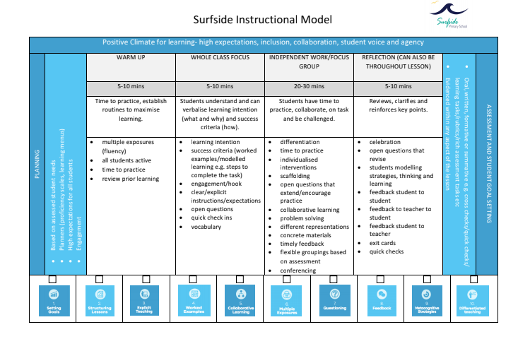
APPENDIX 2
APPENDIX 3
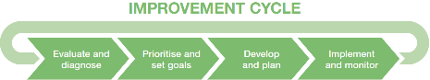
Year Level:  Curriculum Area: |  | AIP Goal Alignment:  Approximate Cycle Length:
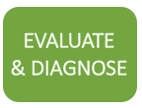  Beginning of Cycle | What’s going on for our learners? How do we know?
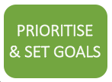 | What does our evidence tell us? Where will we concentrate our energies to make the greatest impact on learning? How will we measure impact?
 | How will we target our teaching to ensure we are meeting all students where they are AT and support where they need to go NEXT? What is currently working, what needs to change, and how will we find out more? What will have the greatest impact on student learning?
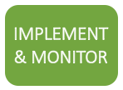 | How will we know along the way that our efforts are making enough of a difference on student progress?
End of cycle reflection | What happened with our learners and our own learning?
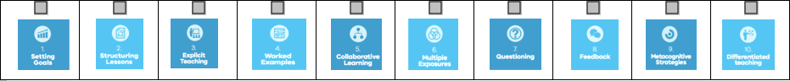

GUIDING QUESTIONS
Beginning of Cycle | What do we want students to learn? (eg. Proficiency Scale)  Create, review and refine formative assessment tasks  Individual teachers analyse class data prior to meeting as a team  Create a spreadsheet for team members to capture and analyse entry data  What trends or patterns can you see in the cohort? Are there differences between classes?  What questions does this data raise for us, and can you speculate why these outcomes are occurring?  Students could analyse their own data (student voice)
What aspect of student learning will be the focus for our inquiry?
What are possible evidence-based teaching practices and how will we prioritise them? (eg. HITS, Practice Principles, Pedagogical Model, School Instructional Model)
What new learning might we need to embark on?
Set learning goals for the team and identify evidence that will show goal has been achieved (e.g Maturity Matrix and student data)
Students set own goals and identify the evidence that they will need to achieve goal (student voice)

What is already working well and what evidence would tell us this?
What do we plan to DO that will have the greatest impact on student learning outcomes?
How will we target our teaching to ensure we are meeting all students where they are AT and support where they need to go NEXT?
Show students on the continuum what the next level of learning is (student voice)
Identify professional reading / resources
How and when will we assess learning?

What is the expected impact on learning and how will this be monitored?
What adjustments/modifications do we need along the way?
How can we support best teaching practice for all team members?
How will we respond if our teaching is not achieving its expected impact?
Bring planned ongoing assessments to PLC to identify students who may have stalled to develop an action plan to restart their learning (focus group, new HITS strategy)
If growth has stalled go back to prioritise and set goals
End of cycle reflection | Teachers share growth analysis and indicate which students achieved expected growth (with team, as well as students).  As a unit complete post unit reflection-  What were our successes/challenges?  What will we do differently next time?  What have we learnt and how will this inform our instruction in the future?  For students who did not achieve the expected growth, record names, strengths and weaknesses as this may support future intervention for individual learning plans and/for students with similar needs

APPENDIX 4
SURFSIDE PRIMARY SCHOOL PROFICIENCY SCALE
AREA: Mathematics - Addition and Subtraction YEAR LEVEL: FIVE
DATE UPDATED: 30th April 2019
ENRICHMENT | APPLICATION AND/OR ENRICHMENT  Demonstrations of learning that goes above and beyond ‘at standard’ performance to include in-depth inferences and applications  Students will be able to:  - justify the most efficient strategy for solving a range of problems  - analyse and justify errors in computations performed by themselves and others  - investigate fermi problems involving perimeter and area
AT  E  X  P  E  C  T  E  D  STANDARD | STANDARD  (ESSENTIAL LEARNINGS THAT DEMONSTRATE ACHIEVEMENT OF THE PRIORITISED STANDARD)  The skills, knowledge or dispositions required to be ‘at standard’  Students will be able to:  Estimating  - recognise the usefulness of estimation to check calculations  - Identify the link between estimation and rounding  - use estimation (and rounding) to check the reasonableness of answers to calculations  Addition  - use/apply mental strategies to estimate the result of calculations  - use/apply efficient mental strategies to solve addition problems  - Partitioning/Parts / Split Strategy  - Jump Strategy (number line)  - Compensation (eg; 36 + 19 = 36 + 20-1) / Friendly Numbers Strategy  - use efficient written strategies to solve addition problems  - Vertical Algorithm  - Partitioning/Parts / Split Strategy  - Jump Strategy (number line)  - Compensation (eg; 36 + 19 = 36 + 20-1) / Friendly Numbers Strategy  Subtraction  - use/apply efficient mental strategies to solve subtraction problems  - Jump Strategy (number line)  - Think of Addition  - use efficient written strategies to solve subtraction problems  - Vertical Algorithm  - Jump Strategy (number line)  - Think of Addition  Fractions  - model addition and subtraction problems involving fractions (same denominator)  - solve addition and subtraction problems involving fractions (same denominator)  - using jumps on a number line  - making diagrams of fractions as part of shapes  Digital Technologies  - apply appropriate digital technologies to solve problems  - choose between mental, written and a technology-based computation depending on the nature of the problems and the purpose for computation | Vocabulary:
WORKING TOWARDS EXPECTED STANDARD | PREREQUISITE SKILLS  Focus on fundamental knowledge, simplified procedures and vocabulary  Students will be able to:  - perform mental strategies to solve simple single digit calculations in addition and subtraction  - use a range of written strategies to solve simple problems 2 digit by 2 digit  - understand the relationship between addition and subtraction  - use understanding of place value to rename numbers | Prior Vocabulary:
EMERGING | REQUIRES ASSISTANCE  With help, the student can perform ‘at standard’ expectations
0 | NO UNDERSTANDING  Even with HELP, no understanding or skill demonstrated. These children would be working on an Individual Learning Plan (focusing on different learning goals.)  Even with help, the student cannot perform expectations

APPENDIX 5
Starting Right Learning Menu:
Grade 1, 2021
Key Learning/ Understandings
- To build classroom expectations
- To unpack and understand our school values
- To build a strong classroom community
- To build a positive and growth mindset
- To form a strong and respectful class culture

RESOURCES
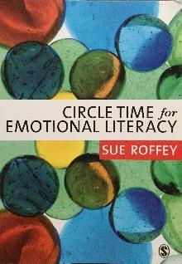
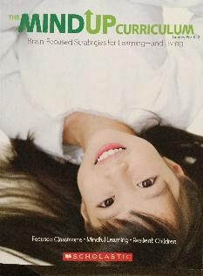
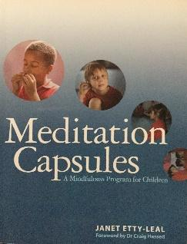
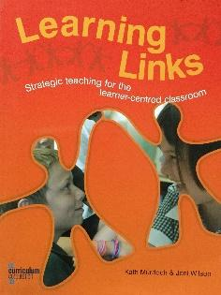
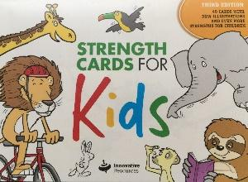

ASSESSMENT: What will we assess and how?
CONCEPTS |  | LEARNING EXPERIENCES | RESOURCES
Building Classroom Community | Warm ups | Inside/outside discussion circle.  If I was an animal / food / toy, I would be … because …  Students share, then move on a number of spaces to create a new partnership.
 | Forming pairs or groups | - On separate cards put names or pictures of things that go together, such as knife and fork, pencil and paper or phrases such as Happy Birthday or Big Bird. When all students have a card, they find their match (partner) | Cards with pairs
 | Transitions | Regaining attention after small group or whole group activity:  - Clapping rhythm  - Singing bowl, bell, music
 | Getting to know one another (circle time games) | Circle time – remind students of the three key rules to circle time.  Circle Time Script day one:  - One person speaks at a time  - Right to pass  - No put downs  Holiday chat using think bugs/talking chips. | Circle Time Script #1 (created by team)  Circle Time Poster
 |  | Books:  FEELINGS  In My Heart-Use the ‘How We’re Feeling’ cards (See Katie). Students to draw a heart and divide it into different sections. Place what they love/feel in the sections.  The Invisible string - Discuss that it’s never too old to feel sad about leaving your family or people you love but we have an invisible string to keep us together. Discuss some ways that we can care for and help the people who may be feeling a little nervous.  Have you Filled a Bucket Today?-Introduce what a bucket filler is, read the book, have “buckets” (cups) on each table and allocate a time each day for students to write a filler. Encourage/recognise students who are being bucket fillers  Today I feel Silly:  The Bad Mood and the Stick  Mr Huff: https://www.pinterest.com.au/pin/469992911096041418/ Students to make a poster “When I’m in a Huff I can…” Make Mr Huff using newspaper and write things they can do when in a huff. e.g. smile, joke, breath, laugh.  MISTAKES  Beautiful Oops-A book about turning mistakes into art. Follow up activity could be give students a page with a scribble on it and they have to turn it into a work of art. Discuss mistakes and what to do.  The Girl Who Never Made Mistakes-also a book about making mistakes.  DIVERSITY  Just the Way we Are: A book about different families and celebrating diversity.  Whoever You Are  We’re All Wonders | Circle Time Script #2  (created by team)  Books
 |  | - Friendship Web-Ball of string...teacher says a name and throws a ball of string to that person . Child catches wool and so on ….creates a web  - Toilet paper challenge. Students to pass around a roll of toilet paper. Take as many sheets as they like. Depending on how many sheets they take, students have to share that many facts about themselves.  - Catch-a-story. Students to use a bean-bag to take it in turns to share a story and continue it when they get the bean bag.  - Two-truths and a lie. Students to come up with two truths and a lie. Share with a partner and the partner has to guess which is true. Take turns.  - Change spots if…e.g. you have a dog, like pizza, went on a plane in the holidays,  - Class Scavenger Hunt- ‘Find Someone Who’...  - Quick change artist. Students to sit in a circle. One person leaves the room and one person changes something about themselves. Student to guess what has changed.  - Clapping game. One student to be in charge of changing the rhythm and one student to be in charge of guessing who is changing the rhythm. | Ball of String  Toliet Paper Roll  Bean-Bag/ball  Scavenger Hunt List
 |  | Personal strengths  - Slinky people- fold coloured paper like an accordian - students write some personal strengths on each section.  - Student strength trace - kids trace around each other with chalk and then draw their strengths inside their person.  - Writing-You’re lucky to have me in your class because…” Students to write their qualities and draw a portrait.  - Strength Cards: Students to sit in a circle and pick a strength, explaining why they chose that.  - Teacher trace: Trace the teacher and students draw inside what they think makes a good teacher  - Student trace: Trace a student and peers draw in the box what a ‘good’ student looks like. | Slinky People Template  Chalk  Stength Cards
 |  | Activities  - All about me pennant (Katie to email)  - Puzzle pieces - decorate with things about you  - All about Me Writing  - Holiday Recount  - Reading: Choosing a ‘Just Right’ book. Read a couple of books. Why did we choose these books? What makes them good book choices?  - Reading: Focus on independent reading, changing books, where book boxes are, what good readers look like (feet still, sitting down, EEKK Reading)  - Family in Indonesian | Pennant About Me  Puzzle Pieces
Values | Respect | - Set up classroom library expectations  - Respect hat - draw a picture of how you show respect.  - Catastrophe Scale-How Big is the Problem? Make A class scale and students to work together to draw what is a small, medium and big problem.  - Big Problem/Little Problem. Give students scenarios to role play. Students to practice and then present in front of the class and discuss if big/little problem and why. Reference catastrophe scale.  - Whole-Body Listening: Play Simon Says to show what whole body listening looks like. Write a poster of what Miss Mac does/doesn’t like. Take a photo showing what is/isn’t whole-body listening. Draw a person to show what whole-body listening looks like (brain, heart, hands, eyes, ears, legs, lips)  - Noise-o-Metre-Discuss what Voice Off, Whisper, Normal and Speak up Look/Sound like. Role play expectations around small group, big group, teacher group work and what it looks like.  - School walk - pick up any rubbish to show respect , jumpers, hats, etc. Show respect to the yard.  - Read ‘Whoever you are’ Mem Fox - discuss respecting others even if you are different. | Catastrophe Scale  Noise-o-metre
 | Honesty | - Honesty book – pinocchio and discussion on why it is so important to be honest. We are honest by…. Scenarios of honesty – add lego to pinocchio face if honest or not  - Read a fable e.g The Boy who Cried Wolf. Discuss book and importance of telling the truth  - What is Honesty? Brainstorm importance of telling the truth the first time. Role Play different scenarios of telling the truth. E.g. You see someone eating another students chips at lunch time.  - The person who is "it" is known as the "lie chaser." The other kids run around yelling out fibs like, "I eat smelly socks for dinner!". The kids must go to a designated "jail area," until another player, the "truth fairy," tags them free only after they make a truthful statement. However, if the child who is freed gets tagged again, he becomes a lie chaser as well, and the game continues until all the "lies" are caught.  - Tower or Trust: Honesty breeds trust. Talks about what trust is and build a “tower of trust” using blocks. This activity creates a powerful visual for children. Practice building and taking blocks down as you give positive and negative examples of honesty. What does it take to knock it down (break someone’s trust) and what does it take to build it up (develop trustworthiness)?
 | Teamwork | - Pass the ball along the feet and along the wall without letting it fall  - Stem boat. Challenge to make a boat that holds the most (gem, counters, pencils) without sinking! 4 x rubber bands 4x straws tin foil 6 pop sticks, clay, small pieces of sponge  - Helping Hands. Who are people we can go to when we are feeling unsure, have a question, sad, need a friend to play with? Students to make a helping hand of 5 people (2 adults, 3 children) on it.  - A good friend is…Read the book Rainbow fish and students make a fish using pieces of paper and write down what a good friend is.  - Children work in teams. All take off shoes and attempt to make a tall tower. Team with the tallest tower wins. Encourage discussion and problem solving.  - Tallest tower with straws, marshmallows/playdough  - Students tangled holding hands. They have to work together to untangle themselves.
 | Achievement | - Positivity Journal-Students to fill in a journal of what the best thing about their day was. Why do we reflect? Importance of positive mindset.  - Read Giraffes Can’t Dance - students write and draw something they can do and something they can’t do yet! (Use mosaic pieces or tissue paper for picture).  - Circle Time/Writing-What you have achieved in your first weeks of Grade 1. What are you proud of? e.g. following class/school expectations, making friends, working on our learning.
 | Class Learning Agreement | - Brainstorm what a good learning environment looks like. Students to draw what they believe should be in their class agreement and put on a white rectangle sheet of paper. Put in an array around the classroom.  - Discuss/Introduce expectations around Plus Ones and Class Dojo’s.
Growth Mindset |  | https://drive.google.com/drive/u/1/folders/1dNRLbhClWfB8YN3-I06-V2oH6WM5GhcJ  Learning Pit-Cut out Dojo’s and ask students where they fit in the ‘pit’. Students could put sticky notes on a time they’ve been in the learning pit or draw their own learning pit.  Dojo has Growth Mindset videos on the app. It has questions you can ask the kids.  ‘The Incredible Power of Yet’, ‘The Magic of Mistakes’
Mindfulness |  | - Smiling Minds  - Brainstorm what 5 star meditators do

