Surfside Primary School Strategic Plan 2018-2021 | Endorsement  Principal: 21/11/17 Mark Huglin [date]  School council: 21/11/17 Adam Stone [date]  Delegate of the  Secretary: [name] [date] | Re-Endorsement (if a Goal, KIS or Target is changed)  ………………………………………[name] [date]  …………………..……… …………[name] [date]  ………………………………………[name] [date] | Re-endorsement (if a Goal, KIS or Target is changed)  ………………………………………[name] [date]  ………………………………………[name] [date]  ………………………………………[name] [date]

School vision | School values | Context and challenges | Intent, rationale and focus  Strategic Intent
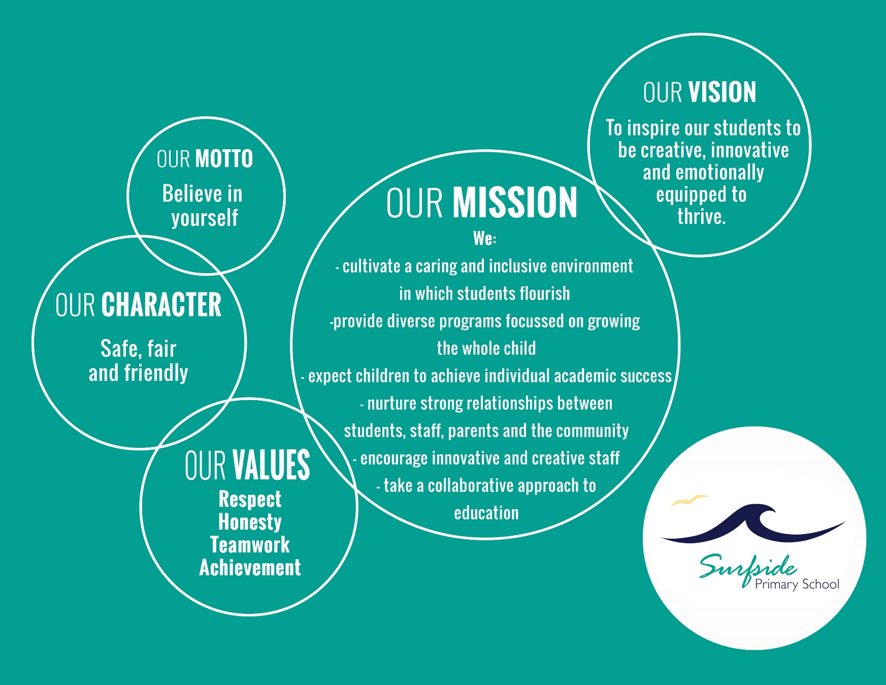 |  | During the strategic plan 2014-2017 Surfside P.S evolved from 280 to 415 students. With this came a major influx of new staff, new families and changes to school structure and organization. Implementing a consistent whole school approach, informed by best practice is the challenge.  The Peer Review process acknowledged that elements of effective practice were present in the school and agreed that whole school consistency would lead to improved learning and engagement outcomes for students.  The Peer Review found that Empowering Students and Building School Pride, is an area for school improvement. Work has been done on creating school values and we are ready to embed these values into measurable actions to impact school culture.  Familiarity with the FISO model, contemporary school improvement language is our work moving forward. The Peer Review recommends:  - undertake further staff familiarisation with the model and the full range of available resources  - adopt the contemporary language to promote consistency and support collaboration  - utilise the FISO Improvement Cycle model to guide the work of the professional learning teams  - utlise the High Impact Teaching Strategies document to support the work of the PLTS  - utilise the FISO Continua of Practice to guide and monitor the two suggested improvement areas for the next strategic period - Building Leadership Teams and Empowering Students and Building School Pride. | The 2017 Peer Review recommended:  That the school leaders establish and guide professional learning teams to promote teacher collaboration, collective inquiry and self-efficacy, and support the implementation of consistent evidence-based teaching and learning practices to improve student learning outcomes.  That teachers be supported to differentiate teaching and learning to engage and challenge all students and to develop consistent student management practices to strengthen the learning culture.  That the school seek additional feedback from students’ and develop students’ capabilities to take ownership of their learning through effective teacher feedback, personal learning goals and authentic choice.  Rationale and Focus -Theory of action  If the capacity of the professional learning team leaders is built to strengthen the professional learning culture then a common and sustained focus on improving student outcomes would be achieved.  If the school established and guided effective professional learning teams then teacher collaboration and development would be strengthened by shared goals and a common approach to improving student outcomes.  If teacher knowledge of students’ learning needs and interests is increased then teaching and learning can be relevant and challenging for all students.  If teachers provide clear learning intentions that are deconstructed with students and provide effective feedback and success criteria then students can answer the questions: Where am I going? How am I doing? Where to next?  If students are able to express their views and contribute to decisions about their learning then they will become more connected to school life and more engaged in their learning.  If students understand themselves as learners then they are better able to manage and monitor their own learning, develop independence and confidence and achieve improved learning outcomes.

Four-year goals  (for improving student achievement, engagement and wellbeing) | Improvement Priorities, Initiatives and/or Dimensions | Key improvement strategies | Targets  (for improving student achievement, engagement and wellbeing)
To achieve optimal learning outcomes for all students. | FISO Priority: Professional Leadership  FISO Initiative: Building Leadership Teams | - Build the knowledge and capacity of school leaders to lead effective professional learning teams as part of a professional learning community.  - Establish professional learning teams that collaborate and collectively inquire into best practice to achieve common goals that will impact on improved classroom practices and lead to improved student outcomes. | Targets based on 2017 benchmarks and trends:  - increase the percentage of students achieving medium and high growth as measured by the NAPLAN Relative Growth data  - increase the percentage of students in the top two Victorian Curriculum bands (A & B)  - increase the percentage of students in the top three NAPLAN bands  - maintain the percentage of matched cohort students in the top three NAPLAN bands from Year 3 to Year 5  - improve the Staff Survey scores for Teacher Collaboration , Academic Emphasis and Collective Efficacy  - improve the proficiency rating against the FISO Building Leadership Team continuum of practice
To maximise student engagement in learning through an active focus on student voice and agency. | FISO Priority:  Positive Climate for Learning  FISO Initiative: Empowering Students and Building School Pride | - Implement systems and approaches that give students a genuine say in the decisions that affect their learning and their lives at school.  - Build a positive classroom culture based on high standards and expectations of behaviour and high levels of student engagement.  - Develop instructive feedback strategies to improve students’ understanding of themselves as learners and to support them to set personal learning goals and take ownership of their own learning. | Targets based on 2017 benchmarks and trends:  - improve the Student Attitudes to School Survey results for the Effective Teaching Practice and Social Engagement domains  - improve the Parent Opinion Survey results for the School Connectedness factor  - improve the proficiency rating against the FISO Empowering Students and Building School Pride continuum of practice.

